Subflows

<https://v3.devflows.devfactory.com/home/flows/1995/status>

<https://v3.devflows.devfactory.com/home/flows/1994/edit>

<https://v3.devflows.devfactory.com/home/flows/1994/status>

<https://v3.devflows.devfactory.com/home/flows/1997/edit>

<https://v3.devflows.devfactory.com/home/flows/1993/edit>

main subflow

<https://v3.devflows.devfactory.com/home/flows/1999/edit>

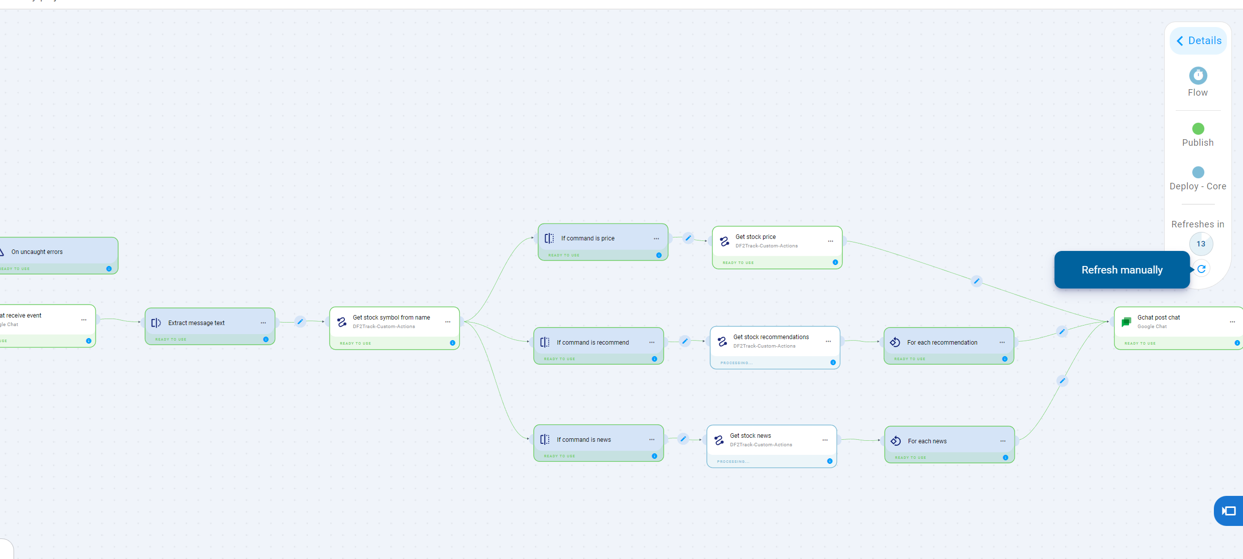

(output taking too much to run… it was running the first time, now it is taking too much time)

